Blood Pressure measurement in smartwatches

Research survey

Source - [How Smartwatches measures Blood Pressure? Check Now!! (digitmize.com)](https://digitmize.com/how-smartwatches-measures-blood-pressure/)

Instead of using a B.P cuff, B.P monitoring watches like Samsung uses optical heart rate sensors to measure Blood **pressure.** These sensors sit near the skin and closely monitor the blood flow without obstructing the blood flow to the arteries.

Pulse wave analysis: Pulse wave analysis is a method used to estimate blood pressure with the help of an optical sensor. Popular [blood pressure smartwatches](https://digitmize.com/best-smartwatch-with-blood-pressure-monitor/) like Samsung Galaxy Watch 3 and Samsung Galaxy Watch Active 2 uses this method.

**Pulse Arrival Time (PAT):**As the name suggests, smartwatches measure the pulse traveling time from the heart to the wrist in this method. The pulse traveling time will be high during high blood pressure.

As per the latest report, the [Fitbit lab](https://digitmize.com/fitbit-blood-pressure-study/) works on this method and successfully finds a correlation between blood pressure and PAT.

**B.P Cuff Method:** The **Omron Heart Guide smartwatch**uses a B.P cuff on the strap that inflates and deflates while measuring the blood pressure. It is the first, and only **FDA-approved smartwatch** currently available in the market today.

Source – [Can a Smartwatch measure Blood Pressure? (smartwatchhelp.com)](https://smartwatchhelp.com/can-smartwatch-measure-blood-pressure/)

This watch comes with an inflatable wristband that is able to measure your blood pressure, which is called an “oscillometric” measurement.

It’s the only smartwatch out there that I personally know of that has an inflatable wristband and the company aims to be medically accurate as well.

Other smartwatches that can measure blood pressure are most likely equipped with the PPG (photoplethysmography) and the ECG (electrocardiogram) sensors, which are able to give a good estimation of what your blood pressure currently is but it won’t be as accurate as the inflatable option.

A cuff-less method called PTT (Pulse Transit Time).

PTT is the time it needs to travel from the heart to another point in the body, which in this case is the wrist because the watch is measuring from there.

The watch is going to need two sensors to measure your blood pressure:

1. a PPG (photoplethysmography) sensor to detect your pulse and
2. an ECG (electrocardiogram) sensor for detecting when the pulse has left the heart.

Source - <https://doi.org/10.1080/21548331.2019.1656991>

**The accuracy of blood pressure measurement by a smartwatch and a portable health device**

Investigated the accuracy and precision of two popular cuff-less devices: the Everlast smartwatch and the BodiMetrics Performance Monitor.

Results:

The average differences between the Everlast watch and reference were 16.9 (13.5) mm Hg for SBP and 8.3 (6.1) mm Hg for DBP.

The average difference between the Bodimetrics performance monitor and the reference was 5.3 (4.7) mm Hg for SBP.

**Conclusions**:

The Everlast smartwatch and the BodiMetrics Performance Monitor we tested are not accurate enough to be used as BP measurement devices.

22/06/22

Contents:

1. Technologies available
2. Different organizations and their techs
3. How are ECG and PPG used?
4. A good article describing recent techs and their pros and cons.
5. Possibility of integration with smartphone
6. Wearables based on api
7. Github repos
8. About Blood pressure
   1. What all things impact bp?
   2. Bp changes in daily life
   3. BP fluctuations: what is not normal?

## **How can a smart watch measure blood pressure?**

As of right now, there are different ways of detecting your blood pressure on a smartwatch.

1. The first one that comes to mind is a cuff-less method called PTT (Pulse Transit Time).

PTT is the time it needs to travel from the heart to another point in the body, which in this case is the wrist because the watch is measuring from there.

The watch is going to need two sensors to measure your blood pressure: a PPG (photoplethysmography) sensor to detect your pulse and an ECG (electrocardiogram) sensor for detecting when the pulse has left the heart.

1. Secondly is a smartwatch with an inflatable wristband that takes an oscillometric measurement.
2. Modified Applanation Tonometry

Omron health care

2018 – Used wrist sized sphygmomanometer (inflatable cuff)

Working on AI technologies

APIs - OMRON API for Developers Our API allows you to integrate an OMRON end user’s blood pressure and/or fitness activity data into your application. You can connect to and interact with our APIs using the programming language and platform of your choice, as long as it supports HTTPS-based request/response scenarios. Features OAuth 2.0 protocol

[7 Smartwatches with Blood Pressure Monitor in India (2022) - wearablestouse.com](https://wearablestouse.com/blog/2022/02/05/blood-pressure-smartwatches-in-india/)

Samsung Galaxy Watch 3

2020 – Using a function called pulse wave analysis (light-emitting diode PPG sensor) which powers the heart rate sensor, calibration needed.

More info: calibrated with a traditional cuff, you can simply tap to “Measure” your blood pressure anytime, anywhere. The device measures blood pressure through pulse wave analysis, which is tracked with the Heart Rate Monitoring sensors. The program then analyses the relationship between the calibration value and the blood pressure change to determine the blood pressure.

# Articles

# Validation of Blood Pressure Measurement Using a Smartwatch in Patients With Parkinson's Disease - <https://doi.org/10.3389%2Ffneur.2021.650929>

# [The use of photoplethysmography for assessing hypertension | npj Digital Medicine (nature.com)](https://www.nature.com/articles/s41746-019-0136-7)

BPro

**Utilises modified applanation tonometry to acquire accurate arterial radial pulse waves.** BPro is a medical-grade cuffless ABPM device which offers user comfort.

* **The sensor plunger is placed on the radial artery and calibrated to the brachial blood pressure.**
* **This calibration allows the radial waveform to be translated into a pressure waveform.**
* **The patented plunger system transfers pressure forces efficiently to the internal pressure sensor.**

### **Asus Vivo watch BP**

The ECG (electrocardiography) and PPG (photoplethysmography) sensors combined can give a good estimation of what your current blood pressure is.

An external file that holds a picture, illustration, etc.
Object name is 41371_2022_675_Fig1_HTML.jpg

How are ECG and PPG used?

ECG data is used as a basis for calculating time, while PPG provides a visual evaluation of the volumetric changes of blood in the tissues during the cardiac cycle. Optical PPG and ECG sensors are already used in wearable devices for measuring heart rate.

A very good article describing recent techs and their pros and cons.

[Wearable blood pressure measurement devices and new approaches in hypertension management: the digital era - PMC (nih.gov)](https://www.ncbi.nlm.nih.gov/pmc/articles/PMC8942176/)

Wearables based on APIs

[Wearables based on APIs, an excellent business opportunity (bbvaapimarket.com)](https://www.bbvaapimarket.com/en/api-world/wearables-based-apis-excellent-business-opportunity/)

[88 Wearable APIs (2022) | ProgrammableWeb](https://www.programmableweb.com/category/wearable/api)

Samsung api example: [Simsense: Sensor overview - Simband](https://www.simband.io/documentation/sensor-module-documentation/simsense/)

Github repos

Link - [Blood-pressure · GitHub Topics · GitHub](https://github.com/topics/blood-pressure)

1. Uses ppg signal obtained by mobile camera by applying image processing method on each frame to get the RGB intensities.

Pros:

* easy

Cons:

* hardware dependent so it needs more testing.
* Camera or the flash of each mobile can affect the reliability of the application
* critical information about the user must be entered

What all things impact BP?

* Lifestyle -sedentary lifestyle --GPS data (male female)
* Environment - poor diet, stress --(eating time, hydration, thirst,
* Age - More common after 50 years of age
* Family history(social feature)
* High salt intake or salt sensitivity(shopping)
* Smoking(Sachin sir – add this task to cv algo to find smoker and degree of smoking)
* Overweight or obesity(api
* Lack of physical activity
* Too much of alcohol consumption(cv to determine alcohol)
* Stress(already a ps)
* Age - above 50 years
* Diabetes \*\*
* Kidney problems \*\*
* Sleep apnoea
* Thyroid or adrenal gland problems \*\*
* Birth control pills \*\*(shopping or ocr)

# Blood Pressure After Exercise

# 120/80 mm Hg is considered as the normal average blood pressure

# the normal range is 90/60 mm Hg to 130/80 mm Hg

# Why do BP increase?

# Increase in BP happens because there is an increase in the demand of oxygen by the muscles (the systolic blood pressure increases during exercise & not much change observed in the diastolic pressure).

# Stress.

# Medication-cold and allergy medications

# Activity-exercise, talking, laughter

# Food and drinks

# What changes blood pressure?

[Why Does Blood Pressure Change Throughout The Day – Fitness Tips for Life](https://www.fitnesstipsforlife.com/why-does-blood-pressure-change-throughout-the-day.html)

* Daily Fluctuations in Blood Pressure
* The Effect of Sleep on Blood Pressure
* Effect of dreaming on bp.
* Effect on eating
* Nationality(geography impact / sea level/ altitude)
* Environment(hot& cold)
* Posture(sitting & lying down)
* Bladder
* Time of the day(lowest during sleep, rises throughout the day, and starts to fall again in the late afternoon)
* Exercise
* Food(eg. Caffeine, tyramine containing)

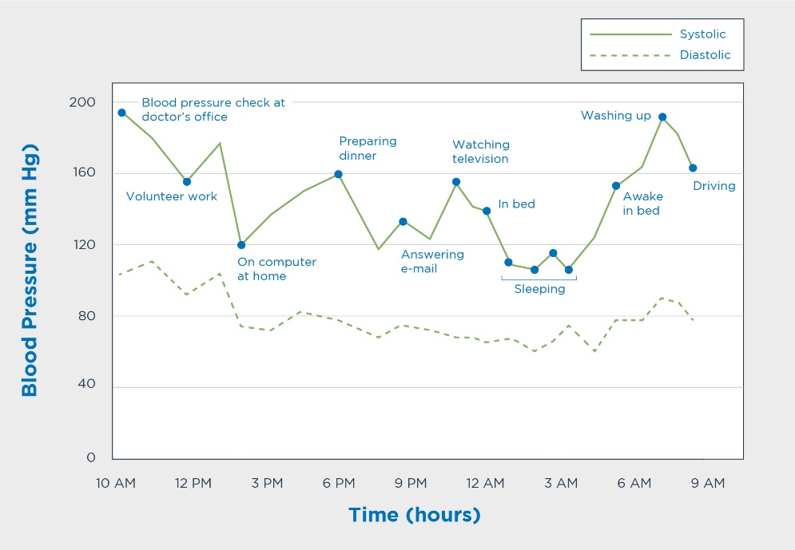

# What is not normal?

# Changes of 25 to 30% during the day are not abnormal.

# blood pressure lowering 24 hours after performing aerobic exercise.

# the blood pressure after exercise falls significantly and does not come back gradually to increase within 30 minutes

# blood pressure lower than 90/60 mm Hg consistently, it should be checked by doctor.

# systolic blood pressure after exercise goes up to 190 mm Hg

# the diastolic blood pressure increase by 10-15 mm Hg during exercise can be underlying coronary artery disease.

# decrease in the blood pressure during exercise(indication of heart problem

Task-Python

1. Basics - Python
2. Accuracy %